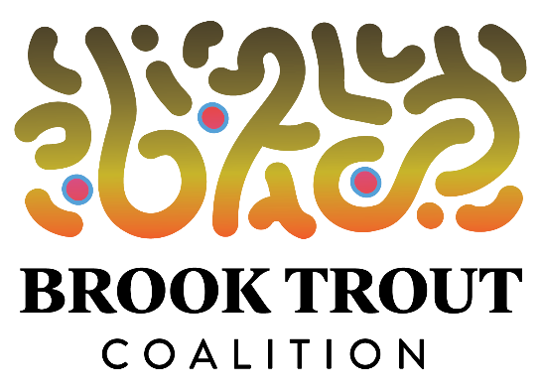

The solution for drunk and rowdy paddlers on the Boardman: self-regulation

February 6, 2020 – Panelists at a lively and informative community forum on paddling sports on the Boardman River told an SRO audience last night that legal constraints and the 1st Amendment restrict law enforcement officers’ ability to respond to community complaints by citing drunken and rowdy paddlers. Their recommendation: Mutual respect and self-regulation.

DNR Lt. Joe Molnar, commander of conservation officers for an 11-county region that includes Grand Traverse County, told audience members who filled the McGuire Room at the Traverse Area District Library that paddlers have a 1st Amendment right to yell, play loud music and engage in other antics that many people find to be offensive. He also said that while state law makes it illegal to operate motorized watercraft while intoxicated, the law does not apply to non-motorized watercrafts such as kayaks, canoes and innertubes.

Molnar also noted that he typically has just two officers assigned to each county and that, in addition to being responsible for wildlife enforcement, they are responsible for enforcing the law on lakes as well as rivers. Referring to complaints from fishermen, hikers and property owners that some local residents and out-of-town visitors who participate in Traverse City’s popular “kayak and brew” events are boozy and obnoxious, Molnar made the following observation: “What is recreation or enjoyment for one user may be totally different for another user.”
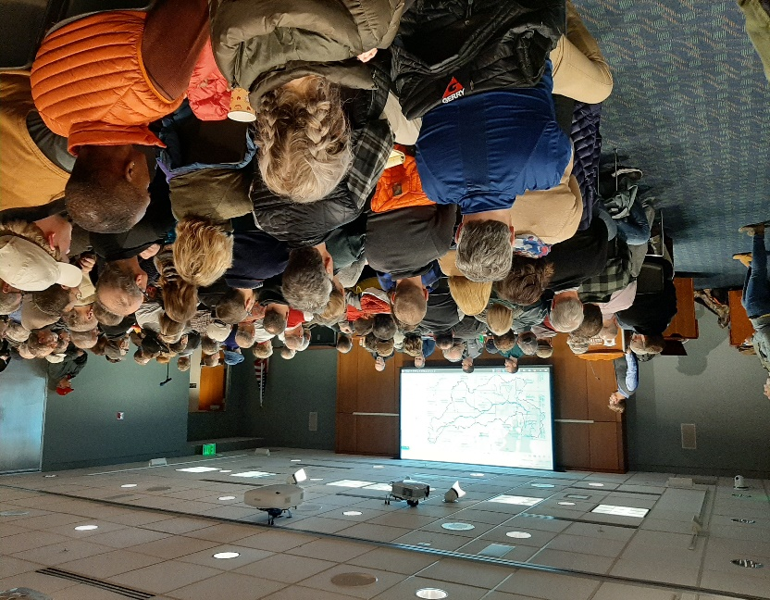
Molnar joined Patrick Ertel of the DNR’s Natural Rivers Program, Steve Largent of the Grand Traverse Conservation District, and Troy Daily, the owner of Paddle for Pints and Kayak Bike and Brew, on a panel discussion that was hosted by the Brook Trout Coalition, Interlochen Public Radio and Traverse City Tourism. The forum was moderated by IPR Executive Director Peter Payette.

Several members of the audience criticized some of the paddlers who participate in the kayak and brew events. One woman said she nearly called 9-1-1 after watching a drunken paddler fall out of his kayak three times.

Daily responded that his clients visit three breweries in four hours. He said they are not allowed to bring beer on their kayaks when they launch at Hull Park. However, he conceded under questioning that some participants bring beer from the breweries that they have visited into their kayaks on the way to the next stop.

“I care about the river,” Daily said. “I’m not going to say that we don’t have problems, but for the amount of people we have, we do a pretty good job.”

Ertel said the DNR has not attempted to determine the “carrying capacity” of the Boardman River – i.e., the maximum number of watercraft that the river can sustain – saying that such a calculation is difficult to achieve. He noted that carrying capacity only applies to commercial usage of the river by businesses such as Daily’s.

Largent has consistently advocated for a recreation plan for the Boardman, saying the river hasn’t yet reached a recreational saturation point, but that it’s close. He said residential and visitor use of the river has steadily increased since the removals of the Brown Bridge, Boardman and Sabin dams, noting that 60 cars were parked at the Brown Bridge boat launch on a recent summer day.

The forum included an unforgettable foot-in-mouth moment when Eric Clone, an employee of The River Outfitters, owned by Tawny Hammond and Amy Clayton, walked up to the microphone and announced that his company offers guided whitewater rafting trips through the Keystone Rapids. He asked Ertel and Molnar how The River Outfitters could “partner” with the DNR.

Not missing a beat, Ertel replied that the company could begin by stopping the tours, noting that the commercial usage of that stretch of the upper Boardman is prohibited. The only exception, he said, is Ranch Rudolph. Ertel didn’t budge when Clone protested that stopping the tours would “bankrupt” the firm.

According to its website, therivertc.com, The River Outfitters hosts “KaBrew” kayak and beer tours as well as a guided $75-per-person “Boardman Rapids Experience.” The website refers to the trip as “the closest thing in Michigan that you can get to full whitewater river rapids.”

