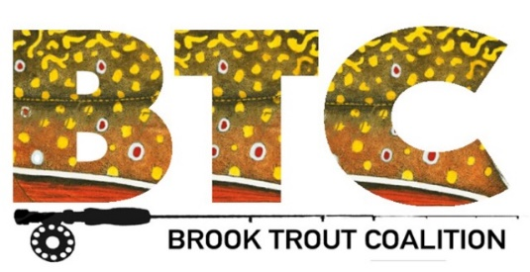

GLTF Officials Provide FishPass Update

November 21, 2018 – In a presentation on Tuesday to the Downtown Development Authority and the Lower Boardman River Leadership Team, Great Lakes Fishery Commission (GLFC) officials reported that the design of the FishPass system is 65% complete. FishPass will replace the Union Street dam and will provide a barrier to allow fish-sorting and fish selection.

The GLFC was formed by a 1955 treaty between Canada and the United States for the purpose of controlling sea lamprey. The goal of FishPass is to provide connectivity of the Boardman River to Lake Michigan by allowing the passage of desirable fish species while providing a barrier to invasive species such as sea lamprey. Twelve rivers were assessed before the Boardman was chosen as the site for FishPass.

Planning for the construction of FishPass began in late 2016 and has involved input from many sources and partners, including an angler workshop that GLFC officials held earlier this year. When completed, FishPass will integrate various sorting technologies that are analogous to single-stream recycling in the recycling industry. Methods include sorting based on migration timing, physical attributes (i.e., shape, size and color) and behavior (i.e., responses to smell, sound and hydraulics).

FishPass is a first-of-its-kind project, which has generated intense local and international interest. GLFC officials said construction of the project will cost $18 to $22 million, with most of the funding coming from federal sources, including the GLFC and the EPA. The project includes a fish-sorting channel and a bypass channel for flood control and recreational use. Also included are a research and education building and recreational facilities such as an amphitheater, an overlook, a bridge, kayak landings, and angler access.

The management of FishPass ultimately will be handed over by GLFC to Traverse City, the Grand Traverse Band of Ottawa and Chippewa Indians, and the Michigan Department of Natural Resources. Oversight will be provided by an advisory board comprised of various federal, state and local agencies. The board also will make decisions about what species are considered to be desirable or non-desirable.

