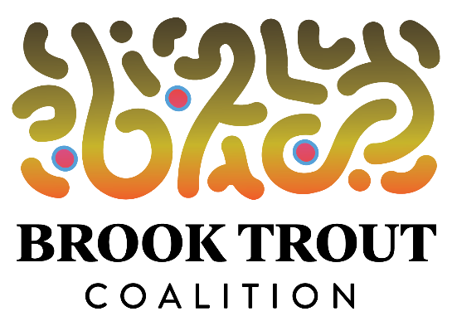

Final Permits for FishPass appear to be Imminent

April 9, 2020 – While most of us are in quarantine and obsessively reading and watching in horror as the coronavirus kills thousands of people and paralyzes the economy, the U.S. Army Corps of Engineers is moving forward with the permitting process for removal of the Union Street Dam.

Yesterday (April 8), the Corps issued a public notice soliciting comments on the in-water Environmental Assessment (EA) for removal of the dam. The notice says that “any person who has a concern or an interest that may be affected by the proposed project may request a public hearing or submit written comments within 15 days of the date of this notice” – i.e., April 23.

The Corps already has completed an EA for the upland (i.e., above-ground) dam-removal work – construction of the FishPass amphitheater, sidewalks, restrooms, parking, etc. The Corps’ Regulatory Branch is separately reviewing the in-water project features, including the potential release of approximately 3,100 cubic yards of toxic sediments that will have to be deposited in a Type II landfill facility, according to the upland EA.

The EA for the upland portion of the project has already concluded that it is unnecessary for the Corps to conduct an Environmental Impact Statement – a far more detailed review that would include a public hearing in Traverse City and would require site visits by the Corps. An EIS also would significantly delay the project, perhaps by a year. On January 7, during a pair of FishPass open houses that the Great Lakes Fishery Commission hosted, Dan Zielinski, the GLFC engineer who leads the project, said he hoped that the project could go out to bid in April. Obviously, April has arrived.

Following are some of the notable conclusions from the EA for the upland portion of the dam removal:

- “Approximately half of the proposed 7,000 CYD of dredged/excavated/cut material (3,100 CYD) will require containment within a Type II landfill facility. One sample was analyzed for polychlorinated biphenyls (PCBs) and they were not detected. Some sediment samples further upstream of Cass Street were also analyzed for PCBs and they were not detected.”
- “The primary detriment of this project is the loss of 0.84 acres of open riverbed water that will be filled and converted to uplands consists of approximately about 0.5 acres of silty/sandy riverbed located upstream of the existing dam and 0.3 acres of gravel/sand located downstream of the dam. The 0.84 acres of existing open waters is not considered unique, scarce or critical habitat.”
- “Bottom-dwelling organisms in the bottomlands areas that are either dredged or filled would be destroyed, but the benthic community would re-colonize the rock/cobble in the 0.8 acres of by-pass channel after the project is completed.”
- “The cutting of approximately 65 trees would occur within the urban park for project implementation. Approximately 20% of the trees proposed for removal are located on the earthen dam or retaining areas where the tree roots may impact the integrity of the existing earthen embankment and are required to be removed for dam safety reasons, regardless of whether a new dam is constructed or not. Half of the trees are located on the north side of the river and do not provide shade to the cold and cool water designated river. Trees will be cut and approximately 65 native trees will be planted to restore riparian vegetation. Removal of the trees would force birds to roost in other areas. The loss of urban riverbank habitat is considered minor to negligible based on the overall river miles of vegetated riverbank within the watershed system.”
- “Review of the proposed Union Street Dam reconstruction FishPass work indicates that the project would not result in adverse environmental effects that significantly affect the quality of the human environment. Nor would it be expected to result in any significant cumulative or long-term adverse environmental effects. Adverse effects would be minor, including short-term noise and air emissions from equipment operation; short term noise would occur during the installation and removal of the components being installed in the fish sorting channels.”
NOTE: Both the EA for the upland portion of the Union Street FishPass Project and the April 8 public notice – including how to submit public comments – can be viewed by clicking on the “Latest News – FishPass” link on our website, www.savemibrooktrout.org.

